HTTP SERVICE

**Prepare new app**

>ng new httpApp

**Generate component**

>ng g user

**Generate Service**

>ng g data

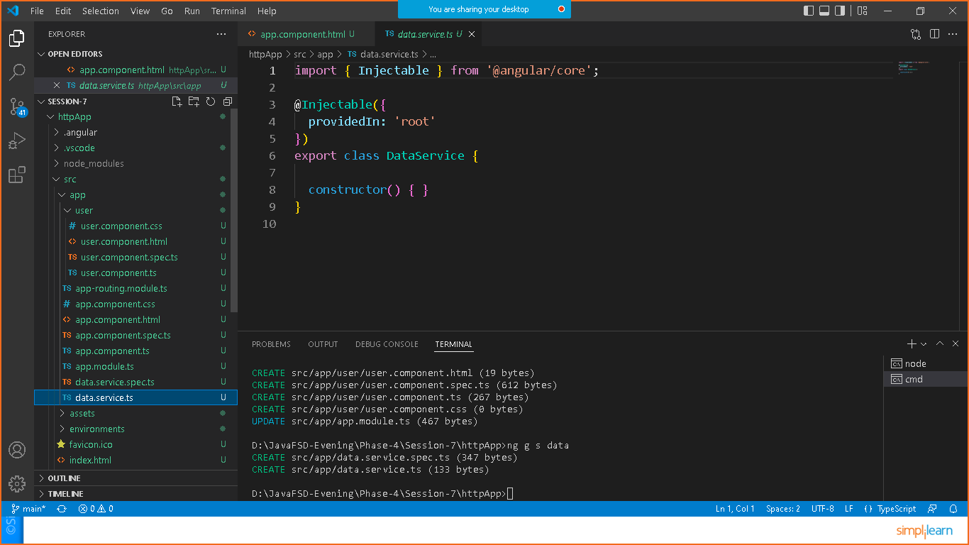

Go to app.component.html and remove the old code and write your own code

<h1>HTTP SERVICE DEMO</h1>

Now goto u**ser.component.ts** file and copy the selector tag and add it to the **app.component.html** file as below

<h1>HTTP SERVICE DEMO</h1>

<app-user></app-user>

Right click on app> new file >userclass.ts

export class UserClass{

    id:number;

    name:string;

    username:string;

    email:string;

}

To remove compile time error in latest angular version

Goto**> ts.config.json**

/* To learn more about this file see: https://angular.io/config/tsconfig. */

{

  "compileOnSave": false,

  "compilerOptions": {

    "baseUrl": "./",

    "strictPropertyInitialization": false,

    "outDir": "./dist/out-tsc",

    "forceConsistentCasingInFileNames": true,

    "strict": true,

    "noImplicitOverride": true,

    "noPropertyAccessFromIndexSignature": true,

    "noImplicitReturns": true,

    "noFallthroughCasesInSwitch": true,

    "sourceMap": true,

    "declaration": false,

    "downlevelIteration": true,

    "experimentalDecorators": true,

    "moduleResolution": "node",

    "importHelpers": true,

    "target": "es2017",

    "module": "es2020",

    "lib": [

      "es2020",

      "dom"

    ]

  },

  "angularCompilerOptions": {

    "enableI18nLegacyMessageIdFormat": false,

    "strictInjectionParameters": true,

    "strictInputAccessModifiers": true,

    "strictTemplates": true

  }

}

data.service.ts

import { Injectable } from '@angular/core';

import {HttpClient} from '@angular/common/http';

import { Observable } from 'rxjs';

import { UserClass } from './userclass';

@Injectable({

  providedIn: 'root'

})

export class DataService {

  //url: https://jsonplaceholder.typicode.com/users

  url:string ="https://jsonplaceholder.typicode.com/users";

  //inject the dependency

  constructor(private http:HttpClient) {

  }

  getAllUsers():Observable<UserClass[]>{

    return this.http.get<UserClass[]>(this.url);

  }

}

User.component.ts

import { Component, OnInit } from '@angular/core';

import { DataService } from '../data.service';

import { UserClass } from '../userclass';

@Component({

  selector: 'app-user',

  templateUrl: './user.component.html',

  styleUrls: ['./user.component.css']

})

export class UserComponent implements OnInit {

  //inject the service

  constructor(private service:DataService) { }

  users:UserClass[];

  ngOnInit(): void {

    this.service.getAllUsers().subscribe(result=>this.users=result);

  }

}

**User.component.html**

<h1 > user details </h1>

<table>

    <thead>

      <tr>

         <th>Id</th><th>Name</th><th>UserName</th><th>Email</th>

      </tr>

     </thead>

      <tbody>

          <tr *ngFor="let u of users">

             <td>{{u.id}}</td>

             <td>{{u.name}}</td>

             <td>{{u.username}}</td>

             <td>{{u.email}}</td>

          </tr>

      </tbody>

</table>